CINDY HEATH
Creative Resume
122 Daniels Road, Plainfield, NH 03781

603-675-9123, cheath58@gmail.com

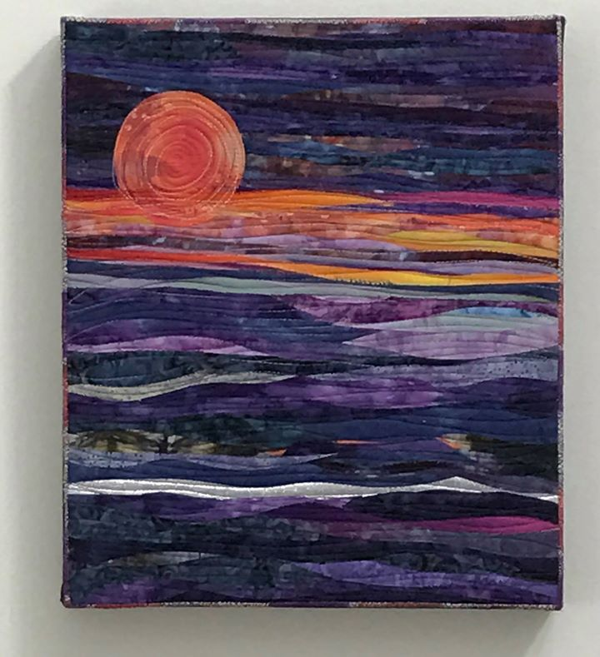

Education Summary
- BS, Physical Education, 1981
University of New Hampshire
Minor, American History;
Elective Art Classes in
pottery, drawing

- Creative Communities Exchange, New England Foundation for the Arts, 2012 (presenter), 2013, 2015

- Master Classes Sue Benner, Katie Pasquini Masopust, 2013, 2014, 2017

- Artist Strength Training
- Art Cloth Mastery Jane Dunnewold, 2015-2018

Professional Affiliations
- Member
Surface Design Association
Studio Art Quilt Associates
Upper Valley Arts Alliance

League of NH Craftsmen

Art Quilt Exhibitions
AVA Gallery Juried Summer Exhibition, Lebanon, NH, 2015, 2017

The Gallery at WREN, “A Fine Line”, Bethlehem, NH, 2015
Osher Gallery at Dartmouth College, “Fiber Fusion”, Hanover, NH, 2017
Plainfield Library Gallery, “A World of Color”, Plainfield, NH, 2017
Mt. Washington Hotel Pop Up Exhibition, Bretton Woods, NH 2016
Long River Studios and Gallery, Lyme, NH 2015 - present
Healing With Art, Dartmouth Hitchcock Medical Center, Lebanon, NH, 2014

Cornish Fair, 2013, 2014, 2016, 2017
Front Porch Collaborative, Lebanon Co-Op Gallery, Lebanon, NH, 2008
Private Holiday Art Show & Sale, Lebanon, NH 2009, 2010
Lebanon College Quilt Show, 2005-2010, Lebanon, NH

Teaching
Quilting Instructor/Retreat Co-Facilitator, 2000-2009
City of Lebanon, NH, Recreation & Parks Department
Town of Wolfeboro, NH, Recreation Department

Quilt Show Curator/Exhibition Coordinator, 2005-2010
Youth Art Instructor, 1983-2005
City of Lebanon, NH, Recreation & Parks Department

Creative Expression, 2017

Philip Read Memorial Library, Plainfield, NH

Music & Voice Over Production
Achoo! Stop the Flu, Health Promotion Video, 2010
Rolling River Productions, Los Angeles, CA

Snatam Kaur & GuruGanesha Singh Concert, 2010
Lebanon Opera House, Lebanon, NH, Mountain Spirit Institute

Monday Evening Concert Series, Thursdays In The Park Series,
Front Porch Music Series, 1985-2010
Lebanon Recreation & Parks Department, Lebanon, NH

Graphic & Website Design
Play Canaan! Community Brochure, Summer & Fall 2011
Upper Valley Healthy Eating Active Living Coalition

Online Tree Care Fact Sheets, 2010
Vermont Urban & Community Forestry Program

Web Site Design & Content Management, 2010 - Present

The Gardening-Guy.com, GP RED News You Can Use, Creative Communities Network, Upper Valley Arts Alliance, Mascoma River Greenway Coalition

Writing & Photography Publications
Lebanon Times, Edible White Mountains Magazine, Appalachian Mountain Club Magazine, Ottawa Citizen, Valley News

Artist Statement

My original design art quilts are the creative expression of my love for colors found in nature – the colors of the earth, sky, fire and water. Inspired by a multitude of shades and images, I like to select fabrics with a monochromatic theme, and create subtle, visual textures and a variety of styles.

